



**QUESTION.1) WHY SHOULD ENGINEERS STUDY ECONOMICS? WHAT IS THE APPLICABILITY? WHAT IS THE DIFFERENT PRINCIPLE OF ENGINEERING ECONOMICS?**

**ANSWER:** ENGINEERS SHOULD STUDY ECONOMICS TO DESIGN AND CONSTRUCT SYSTEMS TO FIND A COST-EFFECTIVE SOLUTION. ENGINEERS SHOULD STUDY ECONOMICS BECAUSE IT PRROVIDES THEM WITH ESSENTIAL KNOWLEDGE AND TOOLS TO MAKE WELL – INFORMED DECISIONS WHEN DEALING WITH VARIOUS PROJECTS, TECHNOLOGIES, AND RESOURCES.

# THE APPLICABILITY OF ENGINEERING ECONOMICS IS TO PROVIDE ENGINEERS WITH THE TOOLS TO:

* **CHECK THE RELEVANCY OF THE PROJECT:** ENGINEERS OFTEN NEED TO EVALUATE DIFFERENT PROJECTS AND CHOOSE THE MOST ECONOMICALLY VIABLE OPTION. THEY NEED TO KNOW ECONOMIC PRINCIPLES TO UNDERSTAND WHETHER A PROJECT WOULD STILL BE RELEVANT UPON ITS COMPLETION AND SERVE ITS INTENDED PURPOSE.
* **EXAMINE /ESTIMATE THE VALUE OF THE PROJECT:** ECONOMICS PRINCIPLES ASSIST WNGINEERS IN ESTIMATING PROJECT COSTS ACCURATELY. KNOWLEDGE ABOUT INFLATION, INTEREST RATES, AND MARKET CONDITIONS, CAN HELP ENGINNERS MAKE MORE REALISTIC AND RELIABLE COST ESTIMATES.
* **JUSTIFY IT FROM AN ENGINEERING VIEWPOINT.**

# ENGINEERING ECONOMICS IS BASED ON A SET OF 7 DIFFERENT PRINCIPLES:

* **DEVELOP THE ALTERNATIVES.**
* **FOCUS ON DIFFERENCES.**
* **USE A CONSISTENT VIEWPOINT.**
* **USE A COMMON UNIT OF MEASUREMENT.**
* **CONSIDER ALL RELEVANT.**
* **STATE UNCERTAINTIES EXPLICITY.**
* **REVISIT OUR DECISION.**

**QUESTION .2) WHAT DO YOU MEAN BY COST OF PRODUCTION? DISTINGUISH BETWEEN FIXED COST AND VARIABLE COST.**

**ANSWER:** THE COST OF PRODUCTION REFERS TO THE TOTAL EXPENSES INCURRED BY A COMPANY OR PRODUCER TO MANUFACTURE OR PROVIDE GOODS AND SERVICES. IT INCLUDES ALL THE COSTS INVOLVED IN THE ENTIRE PRODUCTION PROCESS, FROM THE

ACQUISITION OF RAW MATERIALS TO THE FINISHED PRODUCT’S DISTRIBUTION. THE TOTAL COST OF A PRODUCT IS THE SUM OF ITS TOTAL FIXED COST AND TOTAL VARIABLE COST.

**TOTAL COST (TC) =TOTAL FIXED COST (TFC) + TOTAL VARIABLE COST (TVC)**

**FOR EXAMPLE:** LET’S SAY THAT A COMPANY IS MAKING PRODUCT A, FOR WHICH THEY REQUIRE Rs. 80 WORTH OF SPECIALISED LABOUR AND Rs.70 WORTH OF RAW MATERIALS. THE SPECIALISED LABOUR CANNOT BE DECREASED AS IT IS ESSENTIAL FOR THE MANUFACTURING OF THE PRODUCT. THIS IS THE TFC REQUIRED TO MANUFACTURE PRODUCT A. HOWEVER, THE COST INCURRED BY THE RAW MATERIALS CAN BE DECREASED BY USING DIFFERENT QUALITY MATERIALS OR DIFFERNT QUANTITIES OF SAID MATERIALS. THIS IS THE TVC INVOLVED IN MANUFACTURING THE PRODUCT WHOSE TC IS Rs.150.

|  |  |
| --- | --- |
| **FIXED COST** | **VARIABLE COST** |
| * FIXED COST REFERS TO THOSE EXPENCES WHICH ARE CONSTANT AND CANNOT BE CHANGED IN THE SHORT TERM, REGARDLESS OF THE LEVEL OF PRODUCTION   OR SALES. | * VARIABLE COST REFERS TO THOSE EXPENSES WHICH CAN BE VARIED, EVEN IN THE SHORT TERM TO ACCOMODATE THE CHANGES IN LEVELS OF PRODUCTION OR SALES. |
| * **EXAMPLE: FIXED** COST CAN REFER TO THE LABOUR EMPLOYED IN A COMPANY OR THE PROPERTY TAXES, RENT, AND INSURANCE PREMEMIUMS INCURRED   BY THE COMPANY. | * **EXAMPLE :**VARIABLE COST CAN REFER TO THE QUANTITY OF RAW MATERIALS , EXPENSES INCURRED DURING THE PRODUCTION PROCESS ETC. |

**QUESTION.3) WHAT DO YOU MEAN BY DEMAND? DISTINGUISH BETWEEN INDIVIDUAL DEMAND AND MARKET DEMAND. EXPALIN USIND DIAGRAM.**

**ANSWER:** THE DEMAND FOR ANY COMMODITY, AT A GIVEN PRICE, IS THE QUANTITY OF IT WHICH WILL BE BOUGHT PER UNIT, OF TIME AT THE PRICE. DEMAND ALWAYS REFERS TO DEMAND AT A PRICE.IF DEMAND IS NOT RELATED TO PRICE, IT CONVEYS NO SENSE. ALSO, DEMAND ALWAYS MEANS DEMAND PER UNIT OF TIME.

|  |  |
| --- | --- |
| **INDIVIDUAL DEMNAD** | **MARKET DEMAND** |
| * INDIVIDUAL DEMAND REFERS TO THE QUANTITY OF A GOOD OR SERVICE THAT A SINGLE CONSUMER IS WILLING AND ABLE TO BUY AT A GIVEN PRICE IN A GIVEN TIME   PERIOD. | * MARKET DEMAND REFERS TO THE TOTAL QUANTITY OF A GOOD OR SERVICE THAT ALL CONSUMERS IN A MARKET ARE WILLING AND ABLE TO BUY AT A GIVEN PRICE IN A GIVEN   TIME PERIOD. |
| * THE DEMAND GRAPH OF THIS TYPE | * THE DEMAND GRAPH OF THIS TYPE |

|  |  |
| --- | --- |
| OF DEMAND IS LINEAR WITH THE WANTS OF THE SINGLE PERSON. | OF DEMAND IS THE SUM OF THE WANTS OF MULTIPLE CHOICES. |

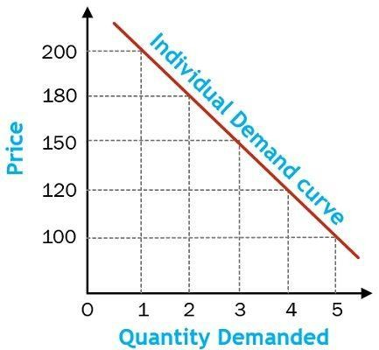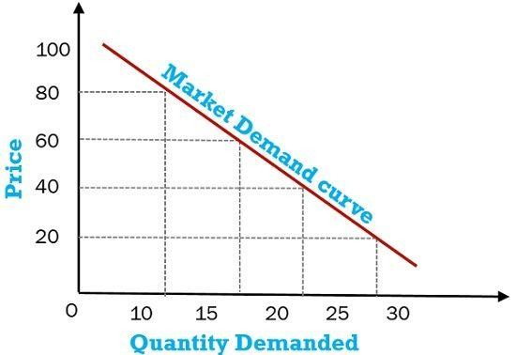

**FIGURE.1. FIGURE.2.**